**Find Best Location to start an Ice Cream Business in Boston Area**

Nisha B

July 5, 2020

# Introduction

## Background

Selecting a location for a creating a new business is a key decision in running a successful business. Business decision makers need to be considered different factors to find right location for the business, such as budgets, market competition and the factors that will affect their demand and increase their revenue.

This project is to assist those who are planning to open a new business such as an ice cream shop and need to find the best location for the shop in a Boston city.

# Business Problem

Starting a new business in city such as Boston can be challenging. Boston has 23 neighborhoods with various places that attract tourists and people to visit. Neighborhoods of Boston are different in terms of different factors that can directly or indirectly affect the success chance of business. It is important to evaluate those 23 neighborhoods based on the factors that affect running a successful business such as the number of competitors, and the potential demand in each of the neighborhoods. Budget limitations in renting or buying a place also play an important role in this decision making especially for small businesses.\ In this project, like to help to find the best neighborhood in Boston to open an Ice Cream shop. An ice cream shop is good to be near a place where many people visit such as near a cinema, park, garden, playground, etc. Also, a neighborhood that has fewer competitors is less risky for starting a new business.

# Data

1. Extract the information about the neighborhoods of Boston need to extract the 23 neighborhoods of Boston along with the Recent home sales in Boston (as an estimate of the renting price of the shop) of each neighborhood. For this purpose, we will use the following website and apply BeautifulSoup website scraping library to extract the data. <http://realestate.boston.com/latest-sales/2020/03/04/recent-home-sales-in-boston-and-cambridge-march-4/>
2. Transform the data into pandas dataframe
3. Use GeoPy Python package to get the latitude and the longitude coordinates of all the neighborhoods of Boston
4. Map the neighborhoods using Folium Python library
5. Use Foursquare API to get information about some venues around these neighborhoods A. Looking for a group of venues in walking distance (500 meters) of each of these neighborhood. We considered Movie Theater, Playground, Park, Garden, Water Park, General Entertainment, Stadium, Amphitheater, Aquarium, Street Art, Beach, Recreation Center, Pedestrian Plaza venues. These venues are places that many people usually visit them for entertainment and hence we will have good demand for ice cream around them. The list of all venue categories of FourSquare can be found in the following link: <https://developer.foursquare.com/docs/resources/categories>

# Methodology

1. Remove neighborhoods where the ice cream shop available already

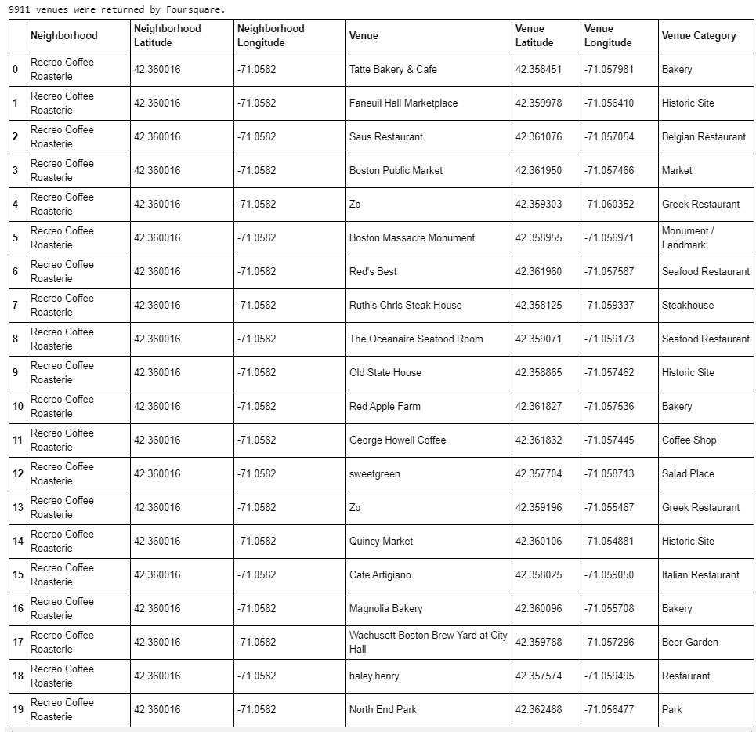

1. Cluster the neighborhoods using k-means to cluster the neighborhood into 5 clusters based on the frequency of different venue categories (except ice-cream shop) around them.

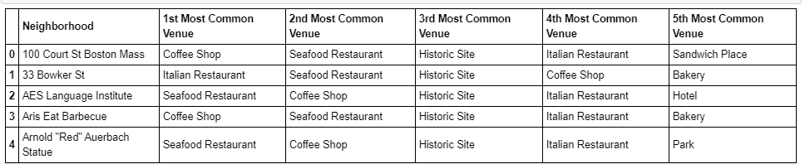

1. Sort the neighborhoods in each cluster based on their average rent price

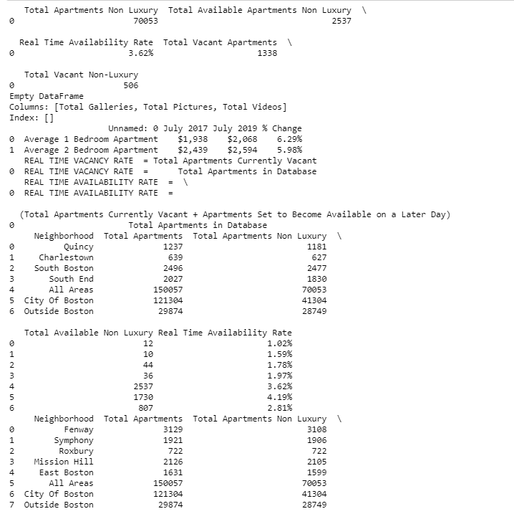

1. Select the neighborhood within the budget limits that has fewer ice-cream shop and more of other venue categories around.

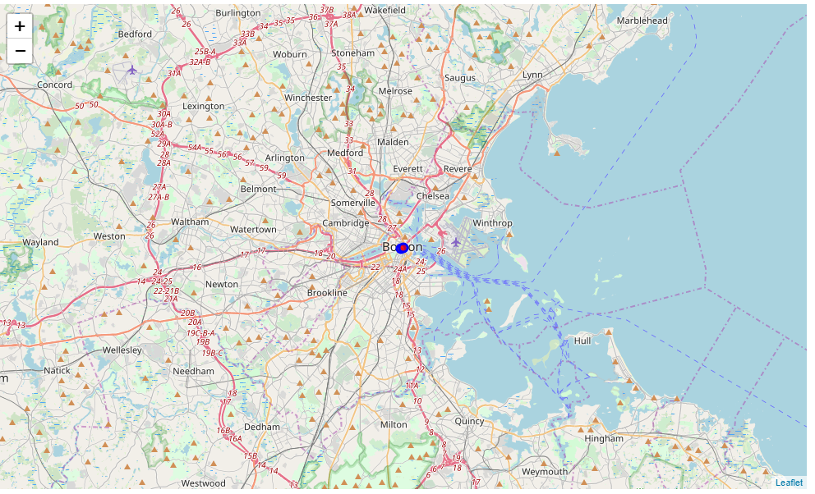

# Results

According to the result of our analysis, downtown Boston (in cluster 1) is the best neighborhood to open an ice cream shop in Boston. It has the greatest number of total venues and is expected to attract many people to visit. This neighborhood with Park, city plaza hall and no ice cream shop. However, the final decision is dependent on the budget of the client to rent the place. According to the budget limitations of the client, we can find other neighborhoods and select the one with the greatest number of venues and a smaller number of ice cream shops around. This clustering can also help our client compare different neighborhoods to make a better decision.

# Conclusion

Used the information about the neighborhoods of Boston to help my client to select the best location to open an ice cream shop in Boston. Considered number of competitors, demand for ice cream, and budget limitations to find the best location options. This project has some limitations. First, we have limited the location options to the neighborhoods of Boston, however considering more specific locations such as areas with apartments can improve the accuracy of our decision. Second, we used the median of one bedroom rent price in each neighborhood as an estimate of the rent price. Third, we limited our investigation for the venues within 500 meter of the neighborhoods and changing it can affect the clusters. Overall Good learning and understood better on a activities needs to be performed by a Data scientist.